

**MASSACHUSETTS INSTITUTE OF TECHNOLOGY**

**RESEARCH ADMINISTRATION SERVICES**

**SUBAWARD AGREEMENT**

This Subaward Agreement (“**Subaward**”), is by and between Massachusetts Institute of Technology, located at 77 Massachusetts Avenue, NE18-901, Cambridge, Massachusetts 02139 (hereinafter referred to as “**MIT**”), and **Auburn University,** located at _____________ (hereinafter referred to as the “**Subawardee**”). “**Party**” shall mean the Subawardee or MIT as the context dictates, and when used in the plural, shall mean the Subawardee and MIT.

**WHEREAS**, MIT has received funding from Election Trust Initiative formerly The Election Performance Project , LLC, an Initiative of the Pew Charitable Trusts (the “**Prime Sponsor**”), in accordance with an agreement effective as of June 17, 2022 (the “**Prime Award**”)—a redacted version of which is incorporated herein as **Attachment D**—for a research project entitled: “Mapping Election Administration and Election Science A Supplement to Learning from Elections.”(the “**Research Project**”); and

**WHEREAS**, MIT desires to have the Subawardee work in connection with this Research Project; and

**WHEREAS**, Subawardee has skilled personnel and facilities available to undertake their efforts on the Research Project.

**NOW, THEREFORE,** the Parties agree as follows:

1. **STATEMENT OF WORK AND PURPOSE.** The purpose (Purpose) of this Subaward Agreement is to Support the Research Project as described above and in Exhibit A of the Prime Award (Attachment D) and, in the Subawardee Scope of Work (Subawardee Research) as described in **Attachment A** to this Subaward Agreement. Subawardee agrees to use reasonable efforts to perform the research program as described in Attachment A.
2. **PRINCIPAL INVESTIGATOR.** The Subawardee Research will be supervised by Dr. Kathleen Hale, the “**Subawardee Principal Investigator**.” Subawardee shall notify MIT in writing of any proposed changes of the Subawardee Principal Investigator. Any successor proposed by Subawardee to replace the Subawardee Principal Investigator must have the prior written approval of MIT. If for any reason a successor acceptable to MIT is not available, this Subaward shall be terminated as provided in Article 9.
3. **PERIOD OF PERFORMANCE.** The period of performance for the Subawardee Research under this Subaward shall be from March 31, 2023 (the “**Effective Date**”) through December 31, 2023 (the “**Completion Date**”). The Completion Date may be modified or extended only by mutual written agreement of the Parties.
4. **REIMBURSEMENT OF COSTS.**
   1. This is a cost reimbursement Subaward. The total estimated cost for performance under this Subaward is **$124,999.**
   2. The amount currently obligated for expenditure under this Subaward is **$124,999** (the “**Authorized Total**”). The Authorized Total is based on Subawardee’s budget attached hereto as **Attachment B** (the “**Subawardee Budget**”).
   3. MIT shall not be obligated to pay Subawardee any amount in excess of the Authorized Total. Costs in excess of the Authorized Total will be incurred at the Subawardee’s sole liability. The Authorized Total may be increased only by mutual agreement duly executed by the Parties.
5. **INVOICES AND PAYMENT.**
   1. The Subawardee shall be compensated, based on invoices as provided below, for actual costs incurred in the performance of the Subawardee Research.
   2. MIT will reimburse Subawardee not more often than monthly and not less frequently than quarterly upon submission of invoices in United States Dollars to [invoices@mit.coupahost.com](mailto:invoices@mit.coupahost.com) and shall reference the MIT Subaward Agreement and Purchase Order Numbers indicated above. Invoices must be signed by an authorized representative of the Subawardee and include a statement materially similar to the following: “*I hereby certify, to the best of my knowledge, and belief, that this invoice is correct and that and that all items invoiced are based upon services rendered consistent with the terms of this subaward agreement.*” Subawardee may use their standard invoice form, but at a minimum shall include current and cumulative costs, and breakdown by major cost category. For reference, a sample invoice has been attached hereto as Attachment C (the “**Sample Invoice**”).
   3. The final invoice shall be a cumulative invoice and shall be submitted to the MIT Business Contact within sixty (60) days of the Completion Date or earlier termination and shall be marked “Final”.
   4. Final payment under this Subaward shall depend upon receipt by MIT of all services, reports, and/or supplies set forth hereunder. MIT reserves the right to withhold final payment of the Subaward until all services, reports and/or supplies set forth hereunder are delivered.
   5. Unless otherwise stipulated by MIT to the contrary, the Subawardee shall submit its final invoice reflecting its indirect costs at the rates that were proposed and approved at time of subaward completion, and this Subaward Agreement shall be fully and finally settled applying such rates, with no further adjustment. Subawardee shall not thereafter have any right to seek further reimbursement as a result of any change in its indirect cost rates. Nothing herein shall authorize Subawardee to be reimbursed in excess of the total budget approved by MIT in writing.
6. **USE AND RETURN OF SUBAWARD FUNDS.**
   1. Subawardee agrees that subaward funds provided will be used exclusively for the Purpose and in accordance with the Budget and Scope of Work. Without limiting MIT’s rights or remedies under this Subaward Agreement, Subaward funds not used for the Purpose must be returned to MIT within 30 days of Completion Date or earlier termination of the Subaward Agreement, whichever is earlier, unless an extension is approved at MIT’s sole discretion.
7. **ACCOUNTING, RECORDS AND AUDIT.** 
   1. The Subawardee shall maintain records to support identifiable charges to the Subawardee Research. The Subawardee shall keep such records for a period of five (5) years from the Completion Date or earlier termination. Expenses must be incurred within the period of performance as agreed to in Article 3 herein.
   2. At its own expense, MIT may monitor and conduct an evaluation of operations under this Subaward Agreement (Evaluation) to confirm that Subaward funds are spent in accordance with this Subaward Agreement during normal business hours with reasonable advance notice to the relevant party. Subawardee agrees to cooperate in the Evaluation and provide such information to MIT or its representatives as necessary.
   3. Subawardee agrees that all financial records pertaining to this Subaward will be made available for review or audit by MIT during normal business hours for a period of five (5) years from the Completion Date or earlier termination.
   4. Subawardee is a participant of the Federal Demonstration Partnership and follows the Federal Audit requirements as indicated in the Uniform Guidance, 2 CFR Subpart F—Audit Requirements. Subawardee’s annual Single Audit report may be found on the following webpage: https://www.auburn.edu/administration/business-finance/pdf/21_uniform-guidance.pdf
8. **REPORTING REQUIREMENTS.** Reports shall be submitted to MIT as follows:
   1. White Paper between 20 and 30 Pages in length associated with topic of election practiceas described in the Statement of Work.
   2. A final technical report shall be submitted to the MIT Principal Investigator by December 31, 2023.
   3. Other reports as may be reasonably requested by MIT.
9. **TERMINATION.** Performance under this Subaward may be terminated by MIT or Subawardee upon thirty (30) days’ prior written notice to MIT’s or Subawardee’s Business Contact noted in Article 15. Performance under this Subaward may be terminated immediately upon notice to the Subawardee, if the Prime Award is terminated by the Prime Sponsor. Further:
   1. Either Party may terminate this Subaward Agreement upon the other Party’s non-compliance with any obligation under this Subaward Agreement and failure to cure within thirty (30) days after receipt of written notice from the non-breaching Party. Such events of non-compliance/breach may include, but are not limited to those described in Article 26 of the Prime Award.
   2. Upon termination of this Subaward Agreement for any reason, without waiver of either Party’s other rights and remedies, (i) Subawardee will cease work under this Subaward Agreement as of the effective date of termination and shall not incur any additional costs or perform any additional work under this Subaward Agreement without MIT’s prior written consent; (ii) a financial report shall be due to MIT within sixty (60) days of the effective date of the termination; (iii) Subawardee shall provide MIT with any Work Product created (and Datasets if applicable) prior to termination, including drafts; and (iv) MIT shall reimburse Subawardee for its costs and noncancelable commitments (unless such amounts for noncancelable commitments were incurred in connection with Subawardee’s breaches of this Subaward Agreement incurred in performance of the Purpose up to and including the effective date of termination, the total of which in no event shall exceed the total amount of the Authorized Total.
   3. Notwithstanding any of the foregoing, either party shall have the right to invoke force majeure and terminate this Subaward in the event that proceeding with the Subawardee Research or material portions thereof would be inconsistent with applicable national, state, or local health advisories and restrictions or University-level policies regarding business travel or attendance at large group gatherings, due to the global public health emergency caused by the novel coronavirus (COVID-19).
10. **CONFIDENTIAL INFORMATION.** Parties do not expect to exchange confidential or proprietary information under this Subaward. Should it become necessary for MIT and Subawardee to exchange such information, the Parties will enter into a separate agreement covering the exchange of such information including the terms and conditions of such exchange. Should the Subawardee require information of the Prime Sponsor which the Prime Sponsor considers to be confidential or proprietary, the Subawardee and Prime Sponsor shall enter into an agreement with regards to such information. For the avoidance of doubt, MIT will not be providing Prime Sponsor confidential information to Subawardee under this Subaward.
11. **PUBLICATIONS, ACKNOWLEDGEMENT & DISCLAIMER.**  The Parties acknowledge that they are each free to publish the results of the research conducted and Work Product (hereinafter defined in Article 12.1) generated under this Subaward Agreement, including but not limited to, through academic journals, conferences or websites. The Parties agree that after publication, the Work Product from the portion of the Purpose described as “Distributed Academic Research” in Exhibit A to the Prime Award will be subject to noncommercial research use open access and/or open licensing requirements.
    1. Acknowledgement. For all written publications and Work Product generated pursuant to this Subaward Agreement and publicly disseminated, Subawardee shall provide an acknowledgment of Prime Sponsor’s role as the funder of such publications and Work Product by placing on all final and/or disseminated versions of such publications and Work Product the following language, “Support for this project was provided by the Election Trust Initiative, LLC, an initiative of the Pew Charitable Trusts.”
    2. Disclaimer. Unless otherwise requested by MIT, for all written publications and Work Product generated pursuant to this Agreement and publicly disseminated, Subawardee shall include the following disclaimer: “The views expressed herein are those of the author(s) and do not necessarily reflect the views of the Election Trust Initiative, LLC, an initiative of the Pew Charitable Trusts.”
12. **INTELLECTUAL PROPERTY.**
    1. Subawardee and MIT Intellectual Property: Title to any intellectual property created in connection with the performance of this Subaward Agreement or any Work Product (as hereinafter defined), created by Subawardee shall vest in the Subawardee in accordance with applicable U.S. laws and the policies of the Subawardee. Work Product consists of the deliverables/milestones and other materials, including drafts thereof, created, or prepared by Subawardee (or MIT) or Subawardee or MIT’s Subcontractors, if any, in the performance or support of the Purpose and using Subaward funds under this Subaward Agreement (“Work Product”). Similarly, title to any intellectual property created in connection with the performance of this Subaward Agreement or any Work Product, created by MIT, shall vest with MIT in accordance with applicable U.S. laws and MIT policies.
    2. MIT & Prime Sponsor License: Subawardee hereby grants to MIT and Prime Sponsor, a nonexclusive, irrevocable (except for breach), perpetual, worldwide, royalty-free, non-transferable, non-sublicensable, license for non-commercial purposes consistent with its not-for-profit mission to use, display, perform, reproduce, publish, copy, archive, excerpt, distribute, and to create derivative works from and otherwise disseminate, in whole or in part, any or all of the Work Product. Notwithstanding the foregoing, the above license may be sublicensed by the Prime Sponsor, to The Pew Charitable Trusts (Pew), provided that Pew is subject to confidentiality obligations no less restrictive than those contained in this Subaward Agreement.
    3. Disclosure of Unpublished Work Product: The Parties agree (i) to use commercially reasonable efforts to protect each other’s unpublished Work Product from unauthorized use or disclosure and to use at least the same degree of care with regard thereto as it uses to protect its own confidential information of a like nature; and (ii) not to disclose or otherwise permit access to the aforementioned unpublished Work Product to any third party, without each other’s prior written consent.
    4. Third Party Infringement. Subawardee agrees that it will make reasonable efforts to ensure that all faculty, staff and researchers of Subawardee (collectively, the “Subawardee Parties”) are required to abide by the Subawardee’s policies and procedures prohibiting unethical behavior and research misconduct (as further defined in Subawardee’s Policies and Procedures) in the performance of their research activities. Subawardee Parties who use software owned or made available by a third party to conduct research activities under this Subaward Agreement shall obtain the appropriate permission or license (if required) and abide by the terms of the applicable software agreement(s) (if any), and any applicable terms of use. MIT may terminate this Agreement pursuant to Article 9 of this Subaward Agreement if violation of any third parties’ intellectual property rights results from Subawardee Parties’ conduct of their activities hereunder. If Subawardee or Subawardee Parties receive notice of any third-party infringement claim against Subawardee in connection with the performance of this Subaward Agreement or any Work Product hereunder, Subawardee shall promptly notify MIT of such notice in writing and take reasonable steps to resolve the dispute.
    5. Jointly Developed Copyright Materials. Copyrightable materials, including computer software, developed jointly in the performance of the Subaward Research by at least one employee or other personnel of Subawardee and one member of the MIT Research Personnel (“Joint Copyright Materials”), shall be jointly owned by the Parties. Unless otherwise agreed by the Parties in writing (which may include entering into an inter-institutional agreement or selecting a mutually-agreeable open source or open access license under which to distribute the Joint Copyright Materials), each Party shall have the independent, unrestricted right to dispose of such Joint Copyright Materials on a non-exclusive basis as it deems appropriate, without any obligation of accounting to the other party.
    6. Limited License to Use MIT Copyright Materials**.** MIT hereby grants to Subawardee a royalty-free, worldwide, non-transferable, non-exclusive right and license to use, reproduce, make derivative works, display, distribute and perform all MIT Copyright Materials arising out of MIT’s work under the Prime Award, including software and its documentation and/or informational databases, solely for Subawardee’s research and educational purposes.
    7. Open Source Licenses., Both Parties acknowledge that the development of openly licensed software or other intellectual property, by either Party individually, or both Parties collectively, is encouraged. MIT and Subawardee agree to (a) release or distribute any MIT Copyright Materials, Subawardee Copyright Materials, and Joint Copyright Materials constituting software code or software documentation under an open source license, as defined by the Open Source Initiative (<https://opensource.org/osd>) preferably the BSD or MIT licenses and (b) release or distribute any other MIT Copyright Materials, Subawardee Copyright Materials, and Joint Copyright Materials (e.g. creative works that are not code, or patentable) under a creative commons license, such as the CC-BY 4.0 International license (<http://creativecommons.org/licenses/by/4.0/>)
    8. Research Results and Data Rights**. “Research Results**” means all data, information, techniques, and other results obtained in the performance of the Subawardee Research, but excluding MIT Software. Subawardee shall grant to MIT the right to use Research Results created in the performance of this Subaward for the purpose of its institutional and educational purposes (including, without limitation, for publication) and to the extent required to meet MIT's obligations to the Prime Sponsor under its Prime Award
13. **USE OF NAMES.** Neither Party shall use the name (including abbreviations or variants), mark or logo of the other Party in any public announcement, advertisement, press release, marketing and promotional materials, or other public disclosure (except to the extent required by applicable law or regulation) without the prior written consent of the other Party (in the case of MIT, MIT’s Institute Office of Communications). Notwithstanding the foregoing, (i) without the consent of MIT, Subawardee may make factual statements during the term of this Agreement that Subawardee is conducting research sponsored by MIT; however, any such statement may not be expressed in a manner that creates the appearance of an endorsement or promotion of Subawardee by MIT or be made in any marketing or advertising, and MIT has the right to require removal of any such statements; and (ii) without the consent of Subawardee, MIT may publicly acknowledge and disclose its support for the research activities being conducted under this Subaward Agreement, including, for example, the investigator’s name, research area and funding amount.
14. **LIMITATION OF LIABILITY**. EACH PARTY SHALL BE RESPONSIBLE FOR ITS NEGLIGENT ACTS OR OMISSIONS AND THE NEGLIGENT ACTS OR OMISSIONS OF ITS EMPLOYEES, OFFICERS, OR DIRECTORS, TO THE EXTENT ALLOWED BY LAW. IN NO EVENT SHALL EITHER PARTY, ITS TRUSTEES, DIRECTORS, OFFICERS, EMPLOYEES, STUDENTS, AND AFFILIATES, BE LIABLE FOR INCIDENTAL OR CONSEQUENTIAL DAMAGES OF ANY KIND, INCLUDING LOST PROFITS, REGARDLESS OF WHETHER THE PARTY WAS ADVISED, HAD OTHER REASON TO KNOW OR IN FACT KNEW OF THE POSSIBILITY OF THE FOREGOING. THIS ARTICLE 14 SHALL SURVIVE THE EXPIRATION OR ANY EARLIER TERMINATION OF THE SUBAWARD
15. **NOTICES.** Any notices required to be given or which shall be given under this Subaward shall be in writing and be addressed to the Parties as shown below.

|  |  |
| --- | --- |
| If to MIT: |  |
| **MIT Principal Investigator**  Charles H Stewart,  Kenan Sahin Distinguished Professor  Department of Political Science  Massachusetts Institute of Technology  77 Massachusetts Avenue  Cambridge, MA 02139 USA  Telephone: (617) 253-3127  Email: ctstewart@mit.edu | **MIT Business Contact**  Jeremy Kennelly, Subaward Administrator  Research Administration Services  Massachusetts Institute of Technology  NE18-901  Cambridge, MA 02139 USA  Telephone: (617) 715-4294  Email: kennelly@mit.edu  Copy to: [subawards@mit.edu](mailto:subawards@mit.edu) |
| If to Subawardee: |  |
| **Subawardee Principal Investigator**  ___________  Telephone: (###) ###-####  Email: _________ | **Subawardee Business Contact**  ___________  Telephone: (###) ###-####  Email: _________ |

1. **DISCLAIMERS OF WARRANTIES.** Neither Party makes any representations or warranties of any kind concerning the Subawardee Research or the MIT Copyrightable Materials, Subawardee Copyrightable Materials or any intellectual property rights therein. Each party hereby disclaims all representations and warranties, express or implied, including, without limitation, warranties of merchantability, fitness for a particular purpose, or non-infringement of such intellectual property rights of Subawardee or MIT, or of any third parties, including theMIT Copyrightable Materials and Subawardee Copyrightable Materials, or the intellectual property rights related to the Copyrightable Materials, as well as the absence of latent or other defects, whether or not discoverable. This Article 16 shall survive the expiration or any earlier termination of this Subaward.
2. **~~INDEMNIFICATION~~**~~. Each Party hereto shall indemnify, defend and hold harmless the other Party and its officers, directors, employees, and agents, from and against any and all third party claims, liabilities, damages, losses, expenses, demands, suits, and judgments, including without limitation reasonable attorneys’ fees and costs (the “Claims”), caused by the negligence or willful misconduct of indemnifying Party or its contractors or employees in the performance of the Purpose under this Subaward Agreement, except to the extent that such Claims are caused by the negligence or willful misconduct of the other Party or its contractors or employees.~~

Each party hereby assumes any and all risks of personal injury and property damage attributable to the negligent acts and omissions of that party and the officers, employees, and agents thereof. Neither party shall be responsible for the personal injury and property damage attributable to the negligent acts and omissions of the other party and the officers, employees, and agents thereof.

1. **ASSIGNMENT.** This Subaward shall be binding upon and inure to the benefit of the Parties hereto and the successors to substantially the entire business and assets of the respective parties hereto. This Subaward shall not be assignable by Subawardee without the prior written consent of MIT; any attempted assignment is void.
2. **~~GOVERNING LAW.~~** ~~The validity and interpretation of this Subaward and the legal relationship of the Parties to it shall be governed by the laws of the Commonwealth of Massachusetts and the applicable U.S. Federal law, without regard to any applicable conflict of law principles.~~

1. **DISPUTE RESOLUTION.** In the event of any dispute arising under this Subaward, written notice of the dispute must be provided to the other Party within thirty (30) days of the events giving rise to the dispute. The Parties shall follow the procedures set forth in the article to facilitate a resolution and attempt to avoid litigation. The Parties shall negotiate in good faith to resolve the dispute within thirty (30) days of receiving notice of the existence of the dispute. In the event the negotiations fail to resolve the dispute, the Parties agree to share the costs of retaining a licensed mediator and to participate, in good faith, with the mediation effort. In the event the mediation effort is unsuccessful, the Parties may pursue other means of dispute resolution, including arbitration, or proceed to litigation in a court of competent jurisdiction. The Parties shall each be responsible for all of their own costs of mediation and/or other dispute resolution. Pending any decision, appeal or judgment on the settlement of any dispute arising under this Subaward, the Subawardee shall proceed diligently with the performance of this Subaward.
2. **EXPORT CONTROLS.** Each Party will comply with all applicable U.S. export control laws and regulations, including, without limitation, the Export Administration Regulations and the U.S. International Traffic in Arms Regulations. Both Parties represent that it will use reasonable efforts to prevent disclosure or delivery to the other Party of any information, materials, tangible items, data, software or technology that carries an export classification more restrictive than EAR 99 (collectively, “Restricted Technology”), without first obtaining the advance written consent of the other Party’s Export Control Officer. If either Party learns that it has or may have disclosed or delivered Restricted Technology to the other Party or otherwise breached this Article, the disclosing Party shall immediately provide detailed written notice to each of the other Party and that Party’s Principal Investigator, and work cooperatively to address the breach.
3. **INCORPORATION OF PRIME AWARD**. This Subaward Agreement is subject to the terms and conditions of the Prime Award included hereto in Attachment D, including all attachments to and incorporations into said Prime Award. Subawardee shall assume towards MIT all obligations, responsibilities, promises, representations, and warranties which MIT, under the Prime Award, assumes towards the Prime Sponsor. Subawardee further assumes all obligations, responsibilities, promises, representations, and warranties that said Prime Award otherwise requires MIT to secure from subrecipients in order for MIT to fulfill its obligations under said Prime Award.
   1. In addition to the terms and conditions explicitly detailed in this Subaward Agreement, the following Prime Award requirements are flowed down to the Subawardee as described in the following Articles: 9, 21, 22, 23, & 24, 28, Exhibit A, & Exhibit C to the Prime Award. In reading the Prime Award flowdown terms, “Grantee” shall be read as “Subawardee” and “Grantor” shall be read as MIT.
   2. The following Prime Award Articles shall not apply to Subawardee: Articles: 1, 3, 4, 6, 10 & 11, 27.
   3. Reports, disclosures, and communications under these terms: Notwithstanding the above, Subawardee shall deliver any reports or other communications, make any disclosures, otherwise deliver any tangible or intangible property and seek any authorizations that are required by this Article 22 to MIT except when the plain text of the Prime Award, if interpreted without regard to the remainder of this Subaward, would expressly permit or require Subawardee to make such conveyance directly to the Prime Sponsor or to Funder.
   4. Prior approval for activity: Subawardee will obtain prior approval from MIT before undertaking any activity for which Prime Sponsor requires prior approval from MIT.
4. EQUIPMENT. For purposes of this Subaward, equipment is defined as non-expendable, tangible personal property having a useful life of more than one year and an acquisition cost that equals or exceeds the lesser of the capitalization level established by the Subawardee for financial statement purposes or $5,000. No equipment is authorized to be purchased under this Subaward.
5. INDEPENDENT CONTRACTOR. In the performance of this Subaward, Subawardee shall be deemed to be an independent contractor and, as such, no employees or staff of Subawardee shall be entitled to any benefits applicable to employees of MIT. The Parties are each free to pursue relationships and opportunities with others similar to those contemplated in this Subaward.
6. PRIOR APPROVAL. Subawardee must acquire prior approval on any of the following changes:

* Substantive changes in Subawardee’s Statement of Work or Budget;
* Absence and/or change in Subawardee Principal Investigator;
* Change in key personnel; and
* No-cost extensions

1. INCORPORATION OF ATTACHMENTS. Any attachments and/or exhibits attached hereto are hereby incorporated into this Subaward.
2. ORDER OF PRECEDENCE. In the event of any conflict between the terms of this Subaward and language set forth in the Attachments, the inconsistency shall be resolved by giving precedence in the following order: (1) Subaward Agreement no. S####; (2) Attachment A (Subawardee Research), Attachment B (Subawardee Budget), and Attachment C; (3) Attachment D, the redacted “Prime Award.”

1. ENTIRE AGREEMENT. Unless otherwise specified, this Subaward and its Attachments embody the entire understanding between MIT and the Subawardee for the Subawardee Research, and any prior or contemporaneous representations, either oral or written, are hereby superseded. No amendments or changes to this Subaward, including without limitation; changes in the statement of work, period of performance or total estimated cost, shall be effective unless made in writing and signed by authorized representatives of the Parties.
2. COUNTERPARTS. This Subaward and any amendment hereto may be executed in counterparts and all such counterparts taken together shall be deemed to constitute one and the same instrument. If this Subaward is executed in counterparts, no signatory hereto will be bound until all the Parties named below have duly executed a counterpart of this Subaward.

IN WITNESS WHEREOF, MIT and the Subawardee, intending to be legally bound, have executed this Subaward as of the last signature date below, by their respective duly authorized representatives.

|  |  |
| --- | --- |
| MASSACHUSETTS INSTITUTE OF TECHNOLOGY | SUBAWARDEE |
| By:__________________________________  Name:_Victoria Grafflin__________________  Title:__Manager, RAS Research Subawards  Date:_________________________________ | By:____________________________________  Name:_________________________________  Title:__________________________________  Date:_________________________________ |

**ATTACHMENT A**

**SUBAWARDEE RESEARCH**

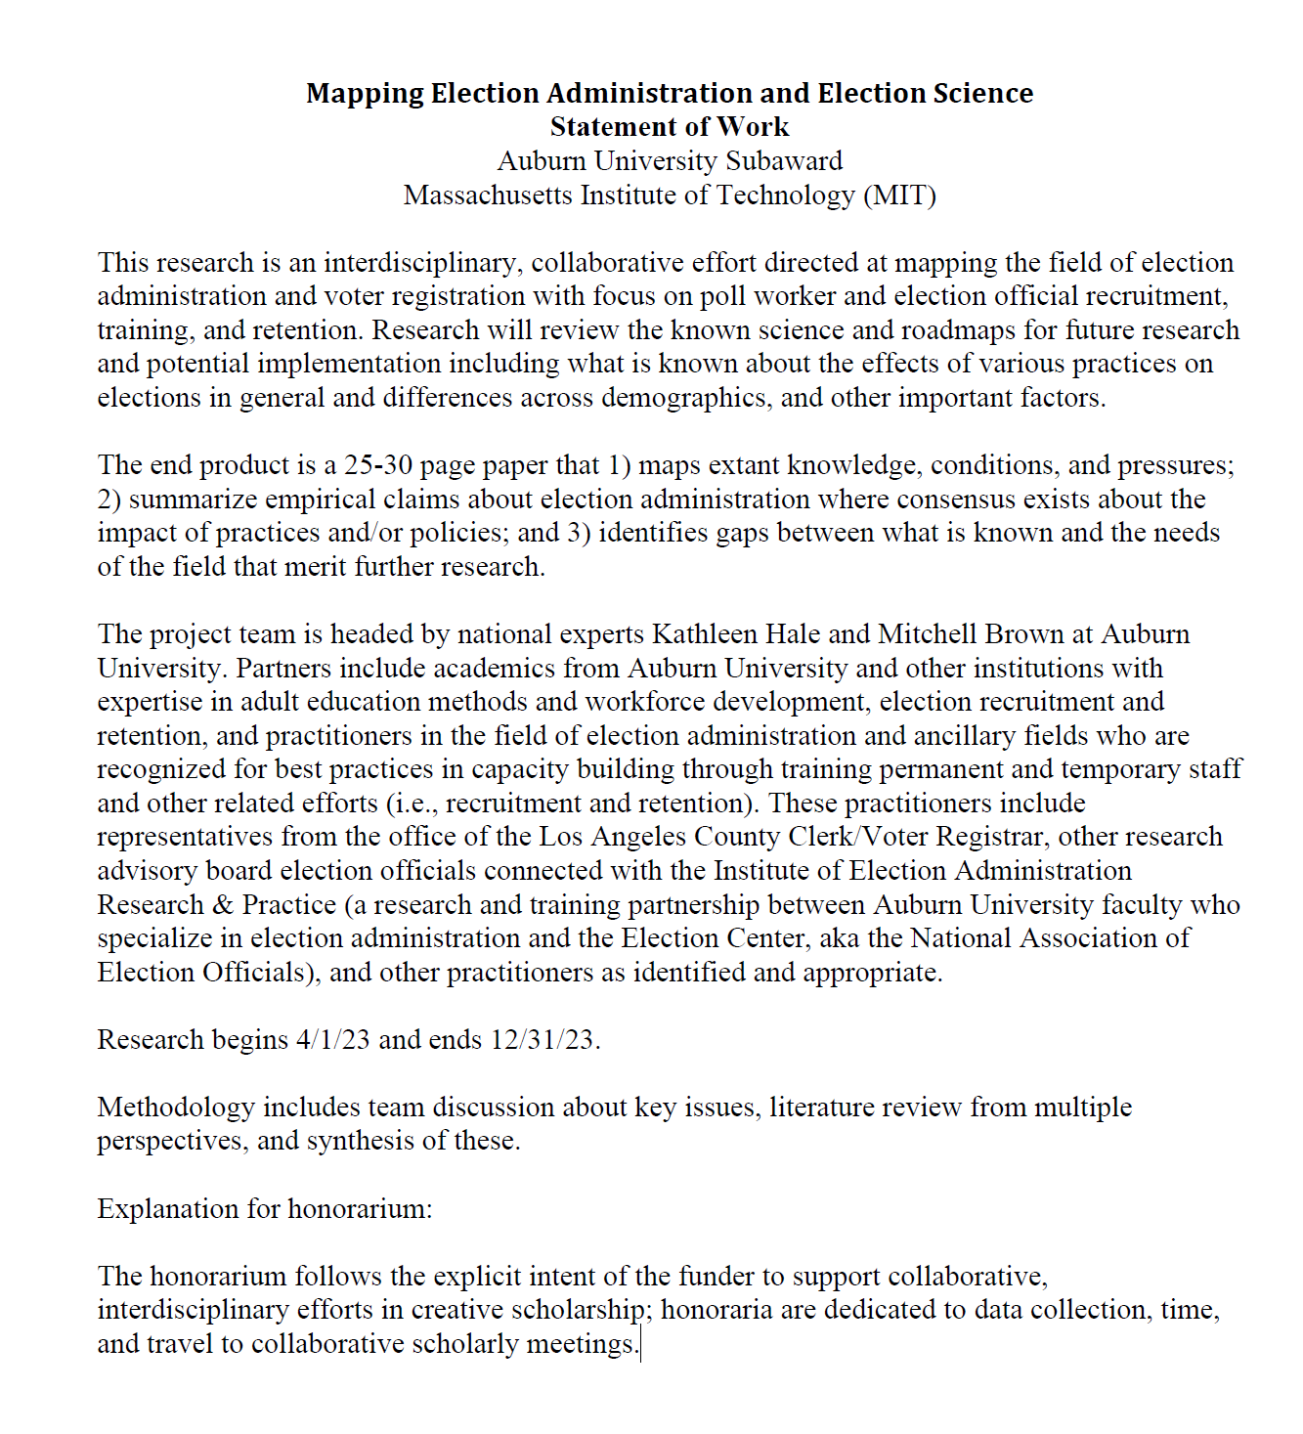

**ATTACHMENT B**

**SUBAWARDEE BUDGET**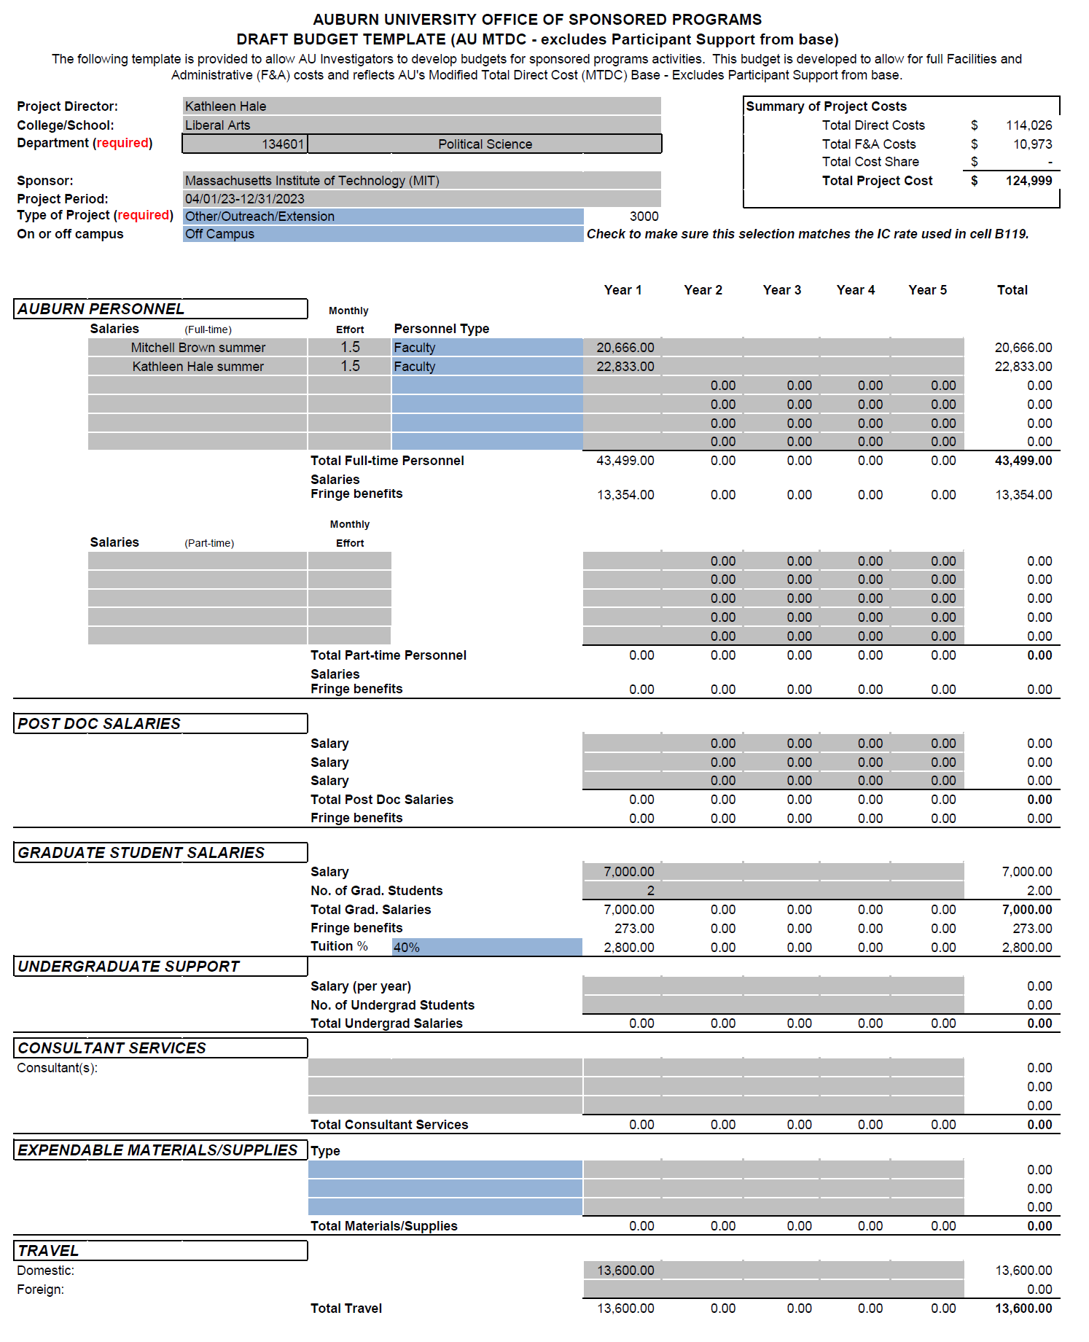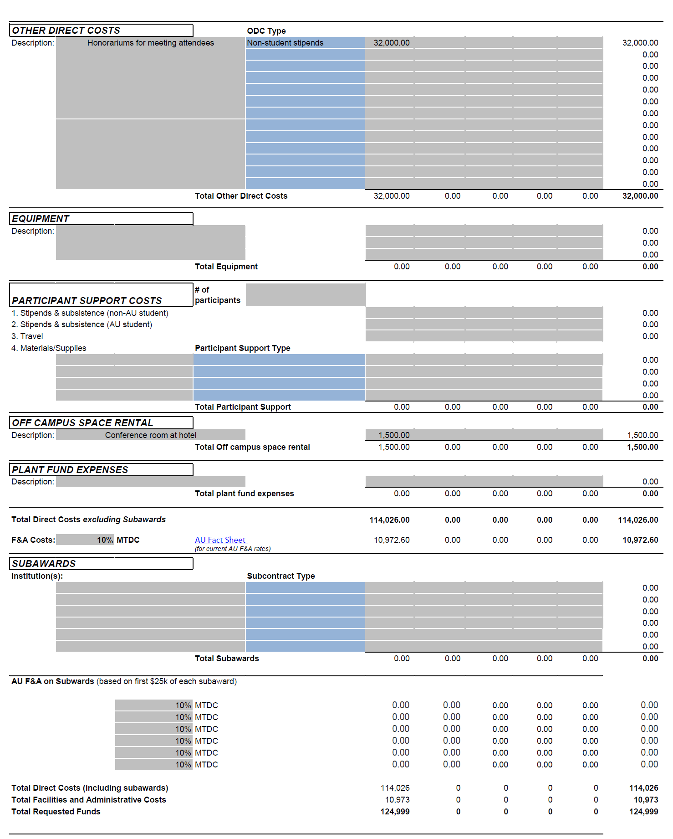

**ATTACHMENT C**

**SAMPLE INVOICE**

FROM:

Invoice Number: _________

Invoice Date: __________

TO: Massachusetts Institute of Technology Subaward Agreement #

77 Massachusetts Avenue, NE18-901 Purchase Order #

Cambridge, MA 02139

[invoices@mit.coupahost.com](mailto:invoices@mit.coupahost.com)

RE: Obligated Amount: $

|  |  |  |
| --- | --- | --- |
| Billing for the period:  From _________ – __________ | CURRENT | CUMULATIVE |
|  |  |  |
|  |  |  |
|  |  |  |
|  |  |  |
| TOTAL |  |  |

By signing this report, I certify to the best of my knowledge and belief that the report is true, complete, and accurate, and the [expenditures](https://www.law.cornell.edu/cfr/text/2/200.415), disbursements and cash receipts are for the purposes and objectives set forth in the terms and conditions of the Subaward Agreement. I am aware that any false, fictitious, or fraudulent information, or the omission of any material fact, may subject me to criminal, civil or administrative penalties for fraud, false statements, false [claims](https://www.law.cornell.edu/cfr/text/2/200.415) or otherwise. ([U.S. Code Title 18, Section 1001](https://www.law.cornell.edu/uscode/text/18/1001) and Title 31, Sections 3729-3730 and 3801-3812).

Signed: _____________________________________ Date: ______________

(Authorized Official)

**ATTACHMENT D**

**PRIME AWARD**

